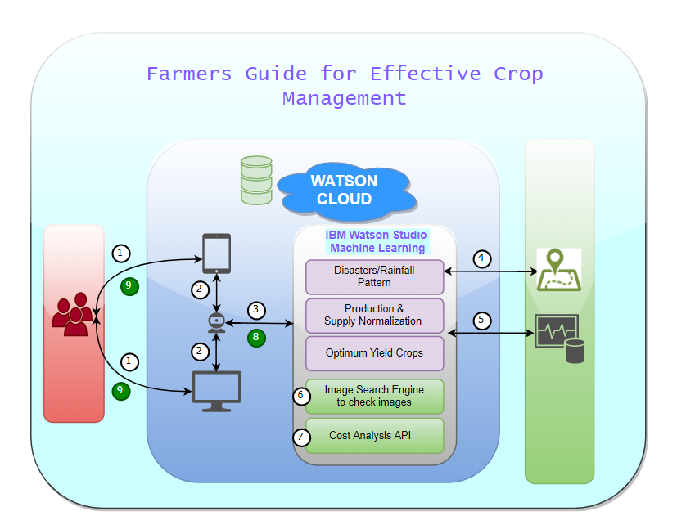

Video Link: <https://youtu.be/kWndtYdsooE>

1. User can access to the portal either through mobile or web application.
2. User can upload a picture and provide required data in the portal or can converse with the chatbot to get the necessary information.
3. Based on the data received with all the inputs and statistical information collected is fed to the machine learning algorithm.
4. Machine learning module utilizes all the historic data like, soil & climatic conditions, optimum yield crops and water resources at the user location using GeoJson maps.
5. AI is used to determine the best possible solution for the given inputs.
6. User can also upload any real time image of the crop related issues. So, ML algorithm is run to analyze to provide best solution to the problem.
7. Additionally, Cost analysis API is used to calculate cost associated with each crop suggestions provided for the user to decide.
8. All the analyzed data such as crop suggestions along with crop and best practices to improve crop yield are provided to the user.
9. Response to user.